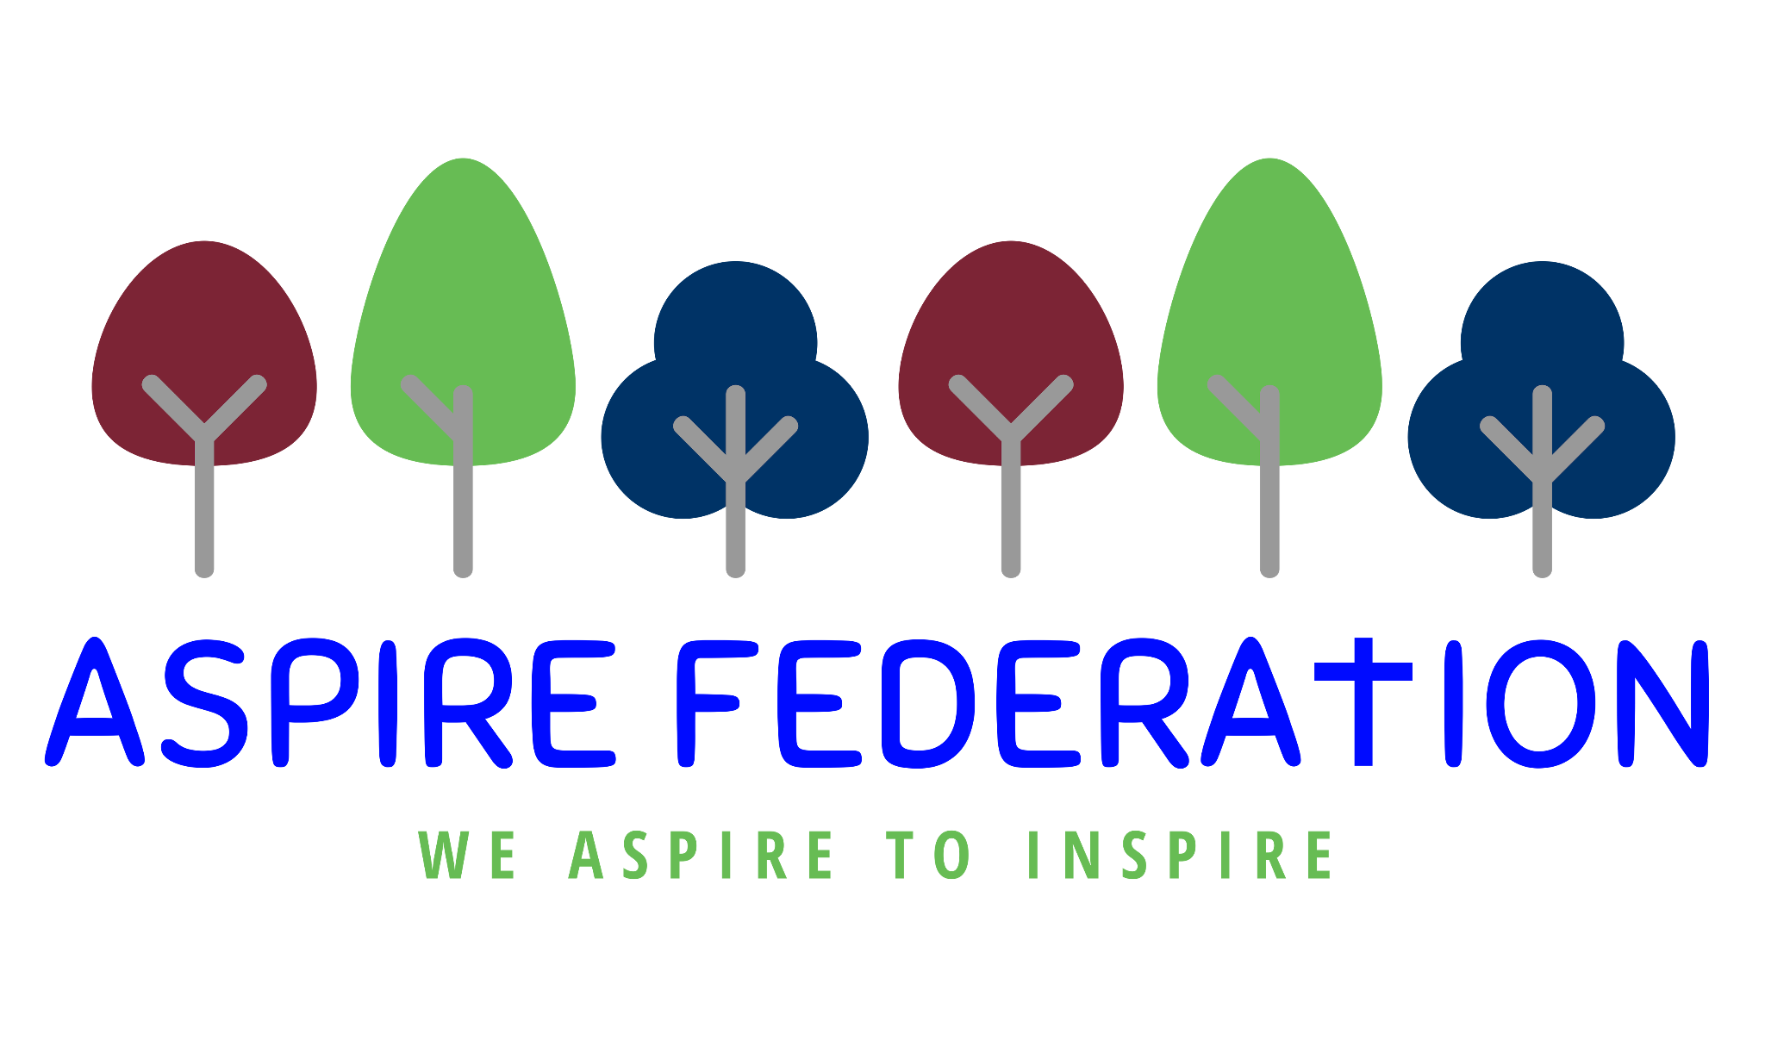
Friday 26th November 2021

Dear parents,
I am writing this week with an update on covid measures within the Aspire school, due to rising cases both nationally and within our school communities. I am also including the usual round up of news and information.

Covid
We have had a number of cases in pupils at Kingswood, and some other cases in parents in the other Aspire schools. As a result we will be putting the following measures back into place from Monday.
- All visitors to any of the Aspire schools will have to wear masks
- Parents will only be able to access the school buildings with an appointment and should contact staff via phone or email if at all possible
- Children, staff and visitors will be asked to wash/santise their hands on entry to the building, after playtimes and before lunch.
- Tables and other surfaces will be regularly wiped down with antibacterial wipes
- Rooms will have windows open to provide ventilation, in accordance with the carbon dioxide monitors we have in classrooms
- Children and staff will be reminded to use tissues when necessary and dispense in the special bins.

At Kingswood where there are a number of pupil cases - 11 at present. We are going to have to take further measures as we have a duty of care to try our best to keep pupils and staff safe. Public health advice is not to close classes or schools so we will be putting the following in place at KINGSWOOD only. These measures will also be put in place at the other schools, if cases rise there.
- Key stages to be back in bubbles inside school. Children have continued to be in Key Stage bubbles on the playground.

- Classes to be 3 to a table at lunchtime and continue to keep to their side of the hall in classes within their KS bubble.

- Wrap-around care to be socially distanced.

- Staff to stay in Key stage bubbles and wear masks in communal areas, socially distanced.

- Parents/carers to hand sanitize as they enter the school grounds.
- Parents/carers to socially distance on drop-off and pick-up - 2 metres between each family. On pick-up, parents/carers to be vigilant with socially distancing when crossing KS areas.

- Visitors, including parents/carers, not to enter the school building.

- Only medical/SEND professionals to enter the building when necessary, wearing a mask.

- All school clubs to be cancelled for the rest of this term.

- All trips to be rescheduled for a later date.

- Christmas Fair to be cancelled.

- Christmas jumper day and dinner will still go ahead as children will be socially distanced in bubbles.

- The Nativity will still go ahead for EYFS/KS1 to gain the wonderful experience of performing. This will be to the rest of the school virtually in classrooms, but no parents/carers to attend.

- All assemblies go back to being virtual.

- Christmas carol assembly to still go ahead for all pupils virtually. Unfortunately parents/carers will be unable to attend.

We do apologise to the Kingswood community that some of the looked forward to Christmas celebrations cannot happen as planned, however our priority has to be that children and staff are kept safe and that we try to limit the spread of the virus as much as possible.

DFE Broadband Pilot project

Thank you to those parents who responded to my letter about the broadband project that we had been invited to be part of by the DFE. I was able to provide vouchers to all families that applied that entitle them to a year's worth of funded broadband. This was available for families who do not have broadband at home currently.

Forest Schools

Year 2 pupils from Leeds and Broomfield, Platts Heath and Ulcombe are today attending a Forest Schools day in Bearsted. The trip will be rearranged for Kingswood pupils in Maple Class. I have just heard from Mrs Steer, Head of School at Leeds and Broomfield who has coordinated these trips that despite the weather the children are thoroughly enjoying the opportunity to be outside learning actively. Year R and 1 trip to Forest schools will be taking place next Friday (3rd December) for all children from Leeds and Broonfield, Platts Heath and Ulcombe. Kingswood’s trip for Chestnut/Sycamore class will be rearranged.

Keeping parents informed

As I have previously, I will write to parents whenever there is a change in advice or when we have to put further restrictions in place due to the number of covid cases. Our aim will always be to keep the children and staff safe. We are very aware that there are only three weeks of term left until Christmas, and we are doing everything we can to make sure that families can enjoy their celebrations. Thanks very much for your ongoing support.

Wishing you all happy family weekends, take care and keep safe,

Kind regards,

Emma Hickling
Executive Headteacher
Aspire Federation

