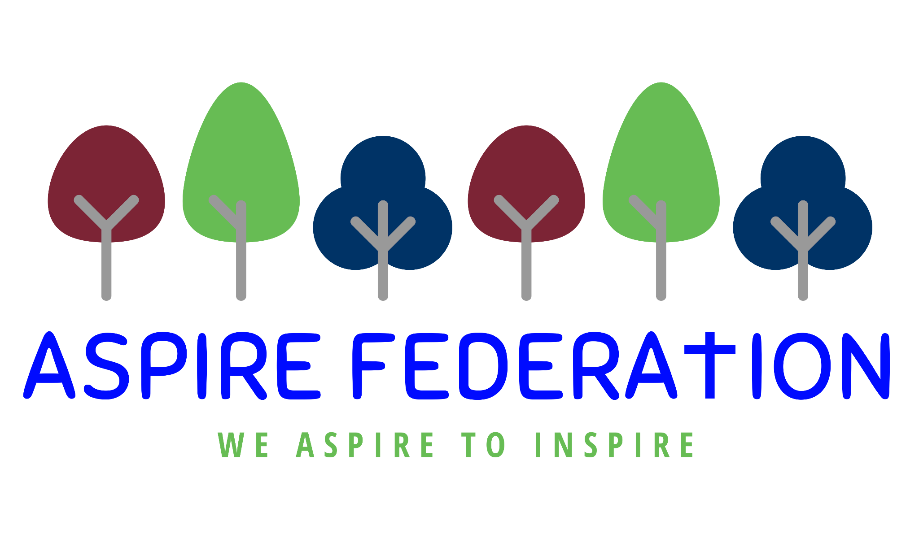

ASPIRE Federation
Protected Characteristics
Year R- Year 6

Year R Protected Characteristics

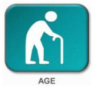 | - All about me- family tree  - Past and present  - Birthdays  - Life Skills - friendships, relationships and family - who are our ‘special/safe’ people.
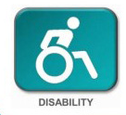 | - Mental Health Awareness Week  - Paralympics  - Life Skills - we are all unique
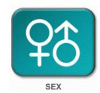 | - Women's History Month  - Gender  - Combating stereotypes around roles and jobs via dance, stories and visitors.  - Art - Female icons  - Women in Computing / STEM - Ada Lovelace / Grace Hopper  - Profile of sport between men and women ie Football
- Black History Month
- Anti-bullying week
- Safer internet day
- Focussing on positive role models such as Mo Farah, Marcus Rashford etc
- People in Brazil
- Music - Diversity in other countries
- Art - GRT influence
- History - Explorers
- European Day of Languages

- Divali
- Chinese New Year
- Christmas- The nativity story
- Easter- the Easter Story and songs, lent, pentecost
- Creation, Incarnation, salvation, God, Gospel - Christianity units
- Stories across faiths - Dharma / Siki / Islam / Judaism and Christian.
- Humanism - Who are Humanists and how do they live?
- Who is Jewish and what do they believe?

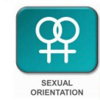 | - Anti-bullying week  - Safer internet day
- Show and Tell- family weddings
- All about me- family tree
- Life Skills - friendships, relationships and family - who are our ‘special/safe’ people.
- Science- Life cycles.
- Science - animals including humans
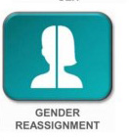 | This area is not covered within the Primary School Curriculum. Any individual instances of anything involving this within school will be dealt with accordingly.

Year 1 Protected Characteristics-

- Timelines and arranging members of staff by their age after discussing the children’s perception of age.
- Science - Life cycles of humans
- Mental Health Awareness Week
- PSHE- Celebrating Differences
- Red Nose day- Awareness of diverse disabilities
- Focus on paralympics.
- Life Skills - uniqueness, individual strengths
- Anti-bullying week
- Safer internet day
- Stories
- Looking at specific sport stars ie Dame Kelly Holmes/Tom Daley
- Life Skills - the family unit - safe and special people in our lives.
- Black History Month
- Anti-bullying week
- Safer internet day
- Focussing on positive role models such as Mo Farah, Marcus Rashford etc
- People in Brazil
- Music - Diversity in other countries
- Art - GRT influence
- History - Explorers
- European Day of Languages
- Divali
- Chinese New Year
- Christmas- The nativity story
- Easter- the Easter Story and songs, lent, pentecost
- Creation, Incarnation, salvation, God, Gospel - Christianity units
- Stories across faiths - Dharma / Siki / Islam / Judaism and Christian.
- Humanism Who are Humanists and how do they live?
- Judaism- Who is Jewish and what do they believe?
- Anti-bullying week
- Safer internet day
- Stories
- Looking at specific sport stars ie Dame Kelly Holmes/Tom Daley
- Life Skills - the family unit - safe and special people in our lives.
- Focusing on weddings in different religious faiths and comparing them.
- Science- Life cycles.
- Science - animals including humans
This area is not covered within the Primary School Curriculum. Any individual instances of anything involving this within school will be dealt with accordingly.

Year 2 Protected Characteristics

- Science - Life cycles of humans
- Art- Artists alive and deceased
- Mental Health Awareness Week
- Red Nose day- Awareness of diverse disabilities
- Paralympics
- Anti-bullying week
- Safer internet day
- Role models
- Specific Sports Stars- Dame Kelly Holmes/Tom Daley
- Black History Month
- Anti-bullying week
- Safer internet day
- Role Models
- Music - diversity in other countries
- Art - GRT influence/promotion of racial equality
- European Day of Languages
- Influential male and female sporting stars of all backgrounds.

- Ramadan and Eid
- Creation, incarnation, Gospel, Salvation - Christianity units
- Hindu Dharma What does it mean to be a Hindu in britain today
- Islam Who is a Muslim and what do they believe?

- Anti-bullying week
- Safer internet day
- Role models
- Specific Sports Stars- Dame Kelly Holmes/Tom Daley
- Marriage Circle Time
- Science- Life cycles
- Animals including humans
This area is not covered within the Primary School Curriculum. Any individual instances of anything involving this within school will be dealt with accordingly.

Year 3 Protected Characteristics-

- History - Prehistoric Britain and life spans
- History - The role of children in the past (Roman Britain, ancient Greece, Egypt)
- Mental Health Awareness Week
- Computing - Chieko Asakawa - blind computer scientist who works to help blind people in their daily lives
- Paralympics
- Women's History Month
- History - The difference in men/women’s role in the past (Roman Britain, ancient Greece, Egypt)
- Skeletal system and muscles- men-women
- Music - Female rock and roll icons
- Art - Female icons
- Computing / Women in STEM - Katerine Johnson and her involvement with the space program
- Profile of sport between men and women ie Football
- Black History Month
- Anti-bullying week
- Safer internet day
- Music - diversity in other countries
- Art - GRT influence/promotion of racial equality
- History - Ancient civilisations in Britain and their travel here.
- European Day of Languages
- Influential male and female sports stars of all backgrounds

- People of God, Salvation, Kingdom of God, Incarnation Christianity units.
- How do people from religious and non religious communities celebrate key festivals?
- How do Sikh people worship and celebrate
- Players observing Ramadam receiving additional breaks during sporting events.
- Men and women playing sport with religious headdress.

- Anti-bullying week
- Safer internet day
- Life cycles of humans and how we develop
- Specific Sports stars ie Dame Kelly Holmes/Tom Daley
This area is not covered within the Primary School Curriculum. Any individual instances of anything involving this within school will be dealt with accordingly.

Year 4 Protected Characteristics-

- Generational Differences
- History - The role of children in the past (Roman Britain, ancient Greece, Egypt)
- Mental Health Awareness Week
- Celebrities- how people can be successful with a disability
- Art- significant artists with disabilities
- Computing - Chieko Asakawa - computer scientist who works to help blind people in their daily lives
- Paralympics
- Women's History Month
- History - The difference in men/women’s role in the past (Roman Britain, ancient Greece, Egypt)
- Music - female rock and roll icons
- Art - female icons
- Computing - Women in STEM - Katherine Johnson and her role in the space program
- Profile of sport between men and women ie Football
- Black History Month
- Anti-bullying week
- Safer internet day
- Significant people of the black community.
- Music - diversity in other countries
- Art - GRT influence/promotion of racial equality
- History - Ancient civilisations in Britain and their travel here.
- European Day of Languages
- Influential male and female sports stars ie Dame Kelly Holmes/Tom Daley
- Creation, incarnation, Gospel, Salvation - Christianity units.
- Humanism-What is Humanism and what do they value?
- Why do some people think that life is a journey and what significant experiences mark this?
- players observing Ramadam to receive additional breaks
- men and women playing sports wearing a headdress
- Anti-bullying week
- Safer internet day
- Keeping up to date with current issues
- PSHE- discussing different types of family.
- Specific Sports stars ie Dame Kelly Holmes/Tom Daley

- PSHE- Discussing different relationships
This area is not covered within the Primary School Curriculum. Any individual instances of anything involving this within school will be dealt with accordingly.

Year 5 Protected Characteristics-

- History - The role of children in the past (Anglo Saxons, Picts & Scots, Vikings, World War 2)
- Mental Health Awareness Week
- Paralympics
- Women's History Month
- History - The difference in men/women’s role in the past (Anglo Saxons, Picts & Scots, Vikings, World War 2)
- Art - Female icons
- Profile of Sport between men and women ie Football
- Black History Month
- Anti-bullying week
- Safer internet day
- Music - diversity in other countries/promotion of racial equality
- Art - GRT influence
- History - Ancient civilisations in Britain and their travel here.
- European Day of Languages
- Influential male and female sports stars of all backgrounds
- God, Incarnation, People of God, Salvation - Christianity units
- How do people from religious and non religious communities celebrate key festivals?
- Green religion? How and why should religious communities do more to care for the Earth?
- Music - links to Holi Fest
- -players observing Rmaadam receiving additional breaks during games
- Anti-bullying week
- Safer internet day
- Kings and Queens- across the ages
- Treatment of woman during different periods.
- Computing pioneers - Alan Turing / Peter Landin
- Specific sports stars ie Dame Kelly Holmes/Tom Daley

- The Menstrual Cycle.
This area is not covered within the Primary School Curriculum. Any individual instances of anything involving this within school will be dealt with accordingly.

Year 6 Protected Characteristics-

- Changes in the body
- Growing up
- Transition to high school
- Social Media- body image
- History - The role of children in the past (Anglo Saxons, Picts & Scots, Vikings, World War 2)
- Life Skills - respect and equality of the elderly.
- Community projects for the elderly
- Mental Health Awareness Week
- Paralympics
- Enrichment Sports Days
- Life Skills - uniqueness, diversity, appearance and worth
- Women's History Month
- History - The difference in men/women’s role in the past (Anglo Saxons, Picts & Scots, Vikings, World War 2)
- Art - Female icons
- Profile of sport between men and women ie Football
- Gender equality/stereotypes/roles

- Black History Month
- Anti-bullying week
- Safer internet day
- Music - diversity in other countries/promotion of racial equality
- Art - GRT influence
- History - Ancient civilisations in Britain and their travel here.
- European Day of Languages
- Influential male and female Sports stars of all backgrounds
- -Creation, Gospel, Salvation, Kingdom of God - Christianity units.
- What can be done to reduce racism. Can religion help?
- ISLAM- What does it mean to be a Muslim in Britain today?
- Music - links to Holi Fest
- Players observing Ramadam having additional rest breaks
- Men and women playing sport wearing a headdress

- Anti-bullying week
- Safer internet day
- Computing pioneers - Alan Turing / Peter Landin
- Specific Sports Stars- Dame Kelly Holmes/Tom Daley
- Life Skills - LGBTQ+ information
- Life Skills - friendships, relationships and family - blended families.
- Sex Education
- Life Skills - the changing body
This area is not covered within the Primary School Curriculum. Any individual instances of anything involving this within school will be dealt with accordingly.

